Export Control

Balancing and

Diagnostic Systems

**SCHENCK RoTec GmbH**

**Declaration of Export Restrictions**

|  |  |  |
| --- | --- | --- |
| Your Invoice / Purchase order no.: |  | Refer to Annex Section **A** |
| Our Purchase order no.: |  | Refer to Annex Section **B** |
| Your vendor no.: |  | Refer to Annex Section **C** |
| Material denomination: |  | Refer to Annex Section **D** |
| Schenck RoTec Material no.: |  | Refer to Annex Section **E** |

**Please complete the following declaration:**

1. Is the product listed in Annex I of the German Foreign Trade and Payments Ordinance?  
   If yes, please file the export list item the product is listed in:

Export list item:        Not applicable.

1. Is the product listed in the annexes of the EU Dual-Use-Regulation (2021/821)?  
   If yes, please file the export list item the product is listed in:

Annex I Item:        Not applicable.

If the product is listed in Annex I: Is the product also listed in Annex IV?

Yes  No

1. Is the product subject to the Export Administration Regulations (EAR) of the USA?  
   If yes, please file the Export Control Classification Number (ECCN) the product is listed in:

ECCN:        Not applicable.

1. Is the product subject to EAR, because it incorporates more than a de-minimis amount of controlled U.S. content (see De Minimis Rule, § 734.4 EAR)?  
   If yes, please file the value share of incorporated US content in relation to our purchase price:

US value share       %  Nicht zutreffend

1. Please provide us with the Customs Tariff No. (HS-Code) applicable to the product:

Customs Tariff No.:

1. Please file the country of origin of the product:

Country of origin:

**Please complete the form with Location, Date, Company Stamp, Name and legally binding Signature!**

……………………………………………………………………………………………………………………………

(Location, Date, Company Stamp, Name in printed letters and legally binding Signature)

**Annex: Explanations to complete the form**

You are probably aware of the fact, that exported and re-exported goods are subject to applicable German, European und US regulations which are strictly to be observed.

For organizational reasons it is not possible to include all required general information in any Quotation, Order conformation, Invoice and Shipping document. Therefore we ask you to forward the following information by utilizing the enclosed form with regard to items and products respectively which are inquired / ordered from your company.

The following is an explanation how to fill out the form correctly. You will find most of the data regarding **A** to **E** also in eMail or other correspondence. Please transcribe the information to the form as shown below.

To **A** Please write down YOUR Invoice or Purchase Order Confirmation No.

To **B** Please transcribe OUR Purchase Order No. from our Purchase Order Document (see below).

To **C** Please transcribe YOUR Vendor No. from our Purchase Order Document (see below).

**Example regarding B and C:**

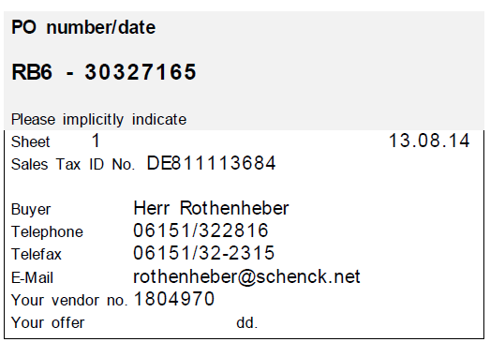

**B**

**C**

To **D** Please provide us with a short description of your Material Denomination, Material No., Type No., etc.

**Example regarding D:** Belt Drive Assembly 4/5UBD, Material No. 123456 or Type No. ABCDEF

To **E** Please transcribe OUR Material No. from our Purchase Order Document (see below).

**Example regarding E:**

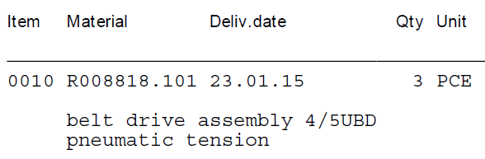

**E**

If you have further questions regarding the form, please do not hesitate to contact us.